CE101 Team Report Assignment

Team Number- A06 (Replace XX with your team number)
Team Members- Sneha, Hasan, Aki, Joshua

CSEE Jira Project URL: 23-24_CE101_lab04team6 - CSEE Jira (essex.ac.uk)

Table of Contents

Chapter 1 The Executive Summary (295 words) 3
Chapter 2 Team Working (608 words) 4
2.I An introduction to Team Working 4
2.II Team Activity Report 4
2.II.a Team's Scrum Meetings, Sprints 4
2.II.b Detailed report of each team members contribution to the project 4
Chapter 3 Product Development (1886 words) 5
3.I An introduction to Product Development 5
3.II The Context 5
3.II.a The Customer/ End User 5
3.II.b Legal and Ethical Matters 5
3.II.c Sustainability 5
3.II.d Health and Safety Matters 5
3.III The Team Product 5
3.III.a Product Description 5
3.III.b Product Demonstration 5
Chapter 4: Project Management (1198 words) 5
4.I An introduction to Project Management 5
4.II Project Management Report 5
4.II.a Summary of Teams Project management in Jira 6
4.II.b An evaluation of the project management 6
Chapter 5: Conclusions (215 words) 7

Chapter 1 The Executive Summary (295 words)

This report points of interest the improvement of an inventive computer program arrangement that leverages fake insights and machine learning to anticipate the probability of heart infection in assorted populaces. By analysing significant wellbeing information, the arrangement points to supply important bits of knowledge to healthcare suppliers and people, encouraging early location, personalized chance appraisals, and moved forward infection management.

The venture was attempted by a devoted group comprising of Sneha Tandon (Scrum Ace and Information Examiner), Hasan Taraman (periodic Scrum Ace and Debugger), Aki Vakkuri (Showcasing Head and Coder), and Joshua Tshabuluka (Analyst and Coder). The group taken after a cross breed extend administration approach, combining components of the PRINCE2 Spry technique and the computer program Advancement Life Cycle (SDLC) prepare to guarantee organized adaptability and ideal administration all through the project's phases.

The item improvement prepares centred on making a user-friendly interface that empowers clients to input important information and get precise chance evaluations. The group tended to lawful and moral contemplations, such as information security and intellectual property assurance, to preserve the astuteness and credibility of the item. Supportability was moreover taken under consideration by optimizing calculations and asset utilization to play down natural impact.

The extend was separated into ten sprints over six months, with each sprint centring on angles of information examination, include determination, and show improvement. Collaboration devices such as Python, Kaggle, Google Colab, and JIRA were utilized to encourage cooperation and track progress.

The coming about program arrangement has the potential to revolutionize heart disease prevention and administration by giving healthcare organizations with quick, exact, and effectively interpretable information investigation. This imaginative item points to spare time, lives, and cash whereas contributing to moved forward wellbeing results for people at hazard of or living with heart illness.

Chapter 2 Team Working (608 words)

2.I An introduction to Team Working

Everyone played a major role in this project. The first to be introduced is Sneha Tandon, who played a role as a Scrum Master and one of the Data Analyst. The next member to introduce is Hasan Taraman, who was Scrum Master on some occasions and debugger for the project. Up next, we talk about Aki Vakkuri, who was our Marketing Head and coder who dealt with the USP of our product. Lastly, Joshua Tshabuluka, who was our Researcher and the coder for our team project.

2.II Team Activity Report

2.II.a Team's Scrum Meetings, Sprints

This report thoroughly evaluates the team's project, including collaboration, product creation, and project management. The main objective of the report is to provide a thorough examination of the project's management, the team's efforts, and the result. The report consists of five chapters, each addressing a different aspect of the project.
Chapter 2 delves into the significance of collaboration for this project. In the initial section, our team developed an understanding of various teamwork concepts by conducting a literature review and examining both in-class and supplemental reading materials. The next part is a review of our efforts throughout the year, highlighting the roles of all team members and referencing the Jira project we collaborated on.
The third chapter discusses product development and is divided into three parts. In the initial section, one of our team members showcases their understanding of the subject through researching literature on product development. The product's legal, ethical, and health and safety environment are addressed in the second section. The third part of our team's product focuses on the written specification, which includes an introduction, description, and demonstration of the product.
Chapter 4 focuses on project management as the main topic of discussion. In the initial part, a team member shows understanding of the topic through research on project management. In the second subsection of the report, the team's Jira project is discussed in relation to project management, followed by an evaluation of Project management in the final section of the chapter.
The final chapter of the report provides overall reflections on the team's efforts, product progress, and project administration. the same input language and with the same number of words, the text can be paraphrased as: "Using the identical input language and keeping the equivalent number of words."
During the project, the team effectively collaborated and communicated, using agile methodologies to adjust to changing needs and guaranteeing on-time product delivery. The product development process was conducted systematically, which involved extensive literature review, considering legal and ethical factors, and creating detailed technical documentation.
My team and I utilized Jira and other project management tools to monitor tasks, allocate resources, and manage risks. This approach enabled me and my team to remain focused and achieve a high-quality outcome that met all their requirements.
This report showcases my team's commitment to excellence throughout every stage of the project, from inception to completion. Highlighting our team's ability to apply theory in practice, conquer challenges, and produce a unique, impactful product was a key aspect of this project's success. Chapter 2 Team Working will benefit from the valuable expertise gained through this research for future academic and professional endeavours.

2.II.b Detailed report of each team members contribution to the project

Sneha – Handled most of the sprint making and completion. Have done coding for the data display and analysis part.
Hasan – Handled some of the sprint making and completion. Have done debugging of the entire code and the testing part.
Aki – Handled some of the coding and few testing and mainly dealt with the presentation of our product.
Joshua – handled some of the coding and few graphic displays for comparison for our data and did majority of the research for our product.

Chapter 3 Product Development (1886 words)

3.I An introduction to Product Development

What is product development?
Product development is the process of creating or editing a product to meet the consumers' needs and the market demand. This is from the idea itself to the design itself, creating prototypes, testing the product and its final commercialization. Throughout this process, teams collaborate to find opportunities to define requirements, and solutions to specific tasks or key issues. Effective product development incorporates insight from market research and user's feedback while also consider technological advancements to refine and optimize the products features, functionality, and user experience.in addition, product development is not merely about the creation of the physical product but also the development of software applications and digital aspects such as service offered. A product’s successful development will result in the creation of a valuable and sustainable solution that will drive a business’ growth.
Our Product development:
The author of the code we were supplied with was from a private data source and provides a key reference for our data analysis on heart disease. The exploratory data analysis (EDA) explains data science in product development and how it analyses the data in a how the system would be giving an insight and to meet the needs of the consumer. By accurately predicting the likelihood of heart disease the code shows a practical use of data to make informed decisions.

3.II The Context

Heart disease is a serious global health condition, with various conditions that can affect the heart’s function, from coronary artery disease to arrhythmias and can easily be prevented. This poses a significant risk to someone's health. To address these issues, it requires early-stage detection to prevent or at least effectively manage a person’s heart disease. Our product aims to provide a strong solution to this problem of identifying the risks associated with heart disease at an early stage. This is using advanced data analytics. Our product assists both healthcare providers and individuals alike to have a clear look at their heart’s health status. Through risk assessments personalized to the user’s data a recommended action can be taken by the user. Our solution enhances health management between healthcare professionals and the patient to reduce the impact of heart disease. Our product contributes to improving the health outcomes for users that are at risk of or living with heart disease. With our products potentially to change the health and management system for those with heart disease, it offers an effective prevention and management system that hopefully will be able to access by all and this reducing the risk of heart disease.

3.II.a The Customer/ End User

The customers/ end users are individuals looking to watch or manage their own risk of heart disease or medical facilities looking to check the risk of heart disease in their patients. Users interact with the program by inputting the relevant patient or personal data to accurately diagnose test results. The simple and easy to use interface allows individuals to use it despite their level of IT experience to again access to the data and give a correct analysis. The program provides a valuable tool for self-assessment and management for user’s health, allowing them to better understand their health status/ conditions and any potential risks that may be involved. The program is a key tool when it comes to patients' care as it greatly helps medical facilities assess the risks and personalizes a treatment plan for them. In conclusion, the customers/ end users benefit from the program as it offers them the ability to get the required support and in the final decision making in the prevention of heart disease.

3.II.b Legal and Ethical Matters

The legal matters of our product are crucial and require careful consideration when it come to the concern of fair use or copy right protection. “A copyright is a type of intellectual property that gives the creator of an original work” It is key that we protect our product’s intellectual properties against any infringement from other companies who are looking to replicate its features. These actions not only pose a threat to our marketing position but our integrity of our code. To mitigate this, we must not use any code that isn’t authorised by the user and must implement a secure measure to protect our product itself and any technology that may be involved in, ensuring that it is unique within the marketplace. To combat this, we must remain vigilant when it comes to checking out for any potential infringements as failure to do so could result in a huge loss of profit for the company. If there is a sign of infringement action must be taken quickly to protect the intellectual properties, not only to protect our investment in our project but also keep our product at the top and thus ensure the success of our product. // . By following the correct ethical standards, we build a trust and credibility with our customers but also contributes to the sustainability of our business.
Ethically, our product is committed to maintaining the integrity and responsibility of business. As from the beginning the ethical considerations have played a part in its development and this extends to ensure the privacy of user's data and must follow the correct measures for securing data. Our product should priorities the accessibility if the user by ensuring the data can be accessed by any one no matter their background.

3.II.c Sustainability

When properly evaluating a product’s sustainability, mass production, energy consumption and device compatibility are key factors. Now while our product my not go under mass production they may require a significant amount of computing power for the infrastructure especially for analysing the data. Cloud computing services from data centres consume significant amounts of energy to run them so making efficient usage of resources and optimisation of algorithms our business can increase its sustainability in the long run. By doing this we can reduce our environmental impact. Even in the nonphysical aspect of product development, sustainability must still be taken into account and must do our best to reduce energy consumption.

3.II.d Health and Safety Matters

Cybersecurity and worker health and safety are two important health and safety factors in our software company. As guardians of confidential information, we've put in place strong risk-reduction measures:
- Employee Training: We prioritize educating our staff, especially those most susceptible to cyber threats, on best practices. This includes organising regular workshops on how to reduce our vulnerability to cyberattacks, such as creating strong passwords, managing the storage and access to data, spotting phishing efforts, and navigating the internet safely.
- Cybersecurity Policies: Precise and explicit policies guide our attempts in fighting against cyberattacks. These policies govern how devices should be used, how data should be accessed, and what to do in the event of a breach.
- Frequent Software Updates: We make sure our systems are up to date through installing regular software updates, decreasing our vulnerability to security flaws in out-of-date operating systems.
- All devices have been fitted with latest and most up-to-date versions of firewalls and anti-virus software with the goal of restricting unauthorised activities and catch malware early on.
- Multi-factor authentication: All employees must use multi-factor authentication for better security. This lowers the risk of unauthorised access by demanding additional verification through mobile numbers to access their accounts.
- Data Backups: In the case of a system breakdown, regular data backups are carried out to minimise loss and speed up recovery.
Adding to the cybersecurity measures, we do our best within our company to take care of our staff’s mental and physical wellbeing by providing ergonomic equipment. The investment in this allows our staff to do their work comfortably and in the correct posture.
In addition to this, we further help our employees by subsidising costs of therapy and eye care as we are aware not everyone can afford to do this regularly and we would like our colleagues to be looked after as they will look after us.

3.III The Team Product

3.III.a Product Description

Our software enables the medical industry to input specific patient data to determine how likely the patient is to have a heart attack. This is crucial as it saves doctors and nurses critical time on diagnosing a patient and if they can get this information then they can sway their testing towards certain causes and be able to treat it quicker than they would if they were to try and find the problem first then diagnose it in a longer process. The software we have created works by outputting a 0 or a 1 after the user has inputted the data required to come back with a result. A 1 lets the user know that a heart attack is very likely to happen and 0 shows that there are no signs for a heart attack to happen soon.
We are currently still in beta and constantly inputting data to it so that our program continues to learn and improve its accuracy. As of now, we have an 86% accuracy to detect heart failures in patients however, we expect this to go lower whilst we continue to input data to teach our software what symptoms and events are more likely to result in heart failure. We do get false negatives and positives with our software and we are working very hard on this, we understand that a false negative is very dangerous and will work on fixing that to the best of our abilities but a false positive usually informs the user that there may not be an instant heart failure but it is imminent and the patient has to adjust their lifestyle immediately to prevent this from occurring.

3.III.b Product Demonstration

Here are a few real-life examples of our product in its developing stages to walk through what it does and how it shows it.
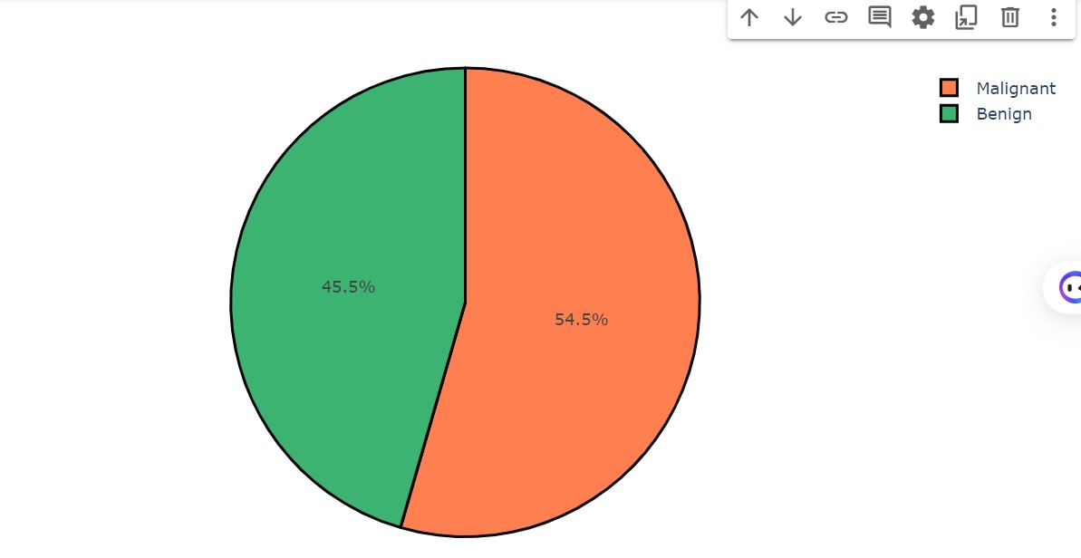
This pi graph shows people who have a benign condition or malignant condition to heart failures. 54.5% patients are malignant to heart disease out of our 300 person data, and this proves how important our product is as most patients in this test set are susceptible to heart disease and if we can use this program to detect it then we can treat them through the condition to allow them to be able to prolong their lives and lead on better lifestyles.
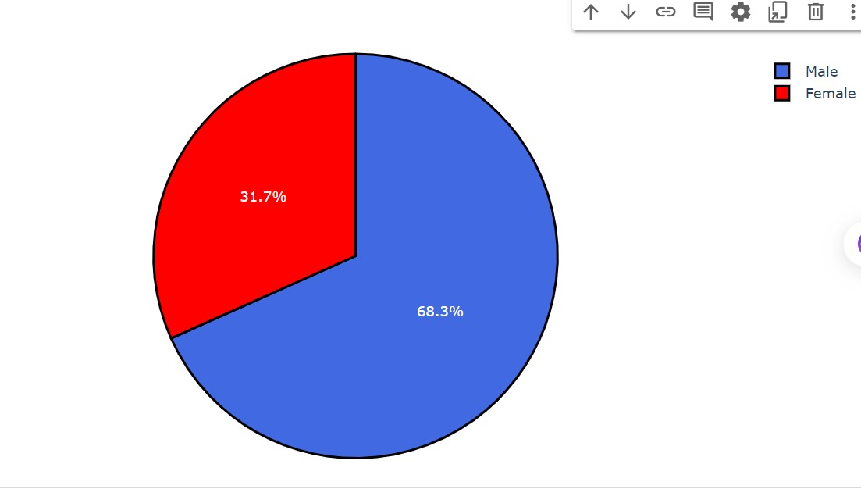
What this chart shows is that 68.3% of people in this test study who are more likely to be in danger to heart diseases are males. This allows us to understand that men are more under risk to suffer from a heart related problem in their lives. Also, our product will be more accurate against men as we have a higher proportion of people who have symptoms of heart disease that are men and that can improve our programs accuracy for men. 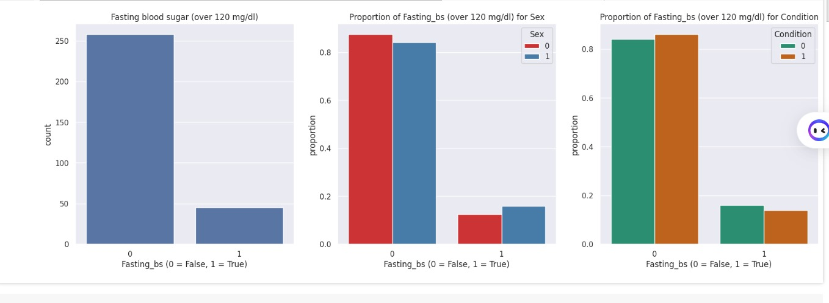This graph shows the difference in blood sugar levels because of fasting vs not fasting in patients and it show that there is a significant drop in the blood sugar levels. We can also see in this chart that the proportion of blood sugar in sex 0 and sex 1 is that sex 0 had a slightly higher blood sugar before fasting and a lower blood sugar than sex 1 whilst fasting. This is important to note as two genders have different levels of blood sugar pre and post fasting. This trend is also evident in people who are malignant to heart disease and people who are benign.

Chapter 4: Project Management (1198 words)

4.I An introduction to Project Management

In the intricate world of software development, the craft of project management involves a multifaceted approach respecting conventional boundaries enforcing requirements of compliance, yet morphing into a dynamic entity harnessing both, the benefits of rigorous implementation of the project management methodology and harvesting the fruits of agile and intelligent innovation born by the project team.
The effort of developing a data analysis solution to predict the likelihood of heart disease occurrence in diverse groups of people combines the use of modern software development tools and methods coupled with the requirement to understand the research data dependencies therein. At the core of the chosen project management approach is the combination of PRINCE2 Agile project methodology, tailored to meet the lightweight governance requirements of a startup project like this, and the Software Development Life Cycle (SDLC) process to guide software development efforts.
This project is a start-up’s ambitious pursuit to quickly launch game-changing data analysis and visualisation capabilities which will be readily usable by healthcare practitioners, providing valuable and actionable insights with little or no training, nor investment in additional equipment.
The choice to implement these two methodologies was not only an attempt to create a structure of otherwise potentially chaotic innovation activity but also a strategic move to encapsulate the project’s iterative nature into a framework with structured flexibility, hence ensuring an optimal mix of governance and agility during phases from conceptualisation to deployment.
The development of a software solution which can utilise artificial intelligence (AI) equipped with machine learning capability to predict the factors impacting the increased likelihood of heart disease occurrence in varying populations, represented an integration of innovative groundbreaking technology solution creation effort and agile project management disciplines. Selective implementation of certain PRINCE2 Agile methods, alongside the Software Development Life Cycle (SDLC) process, formed a structured yet flexible management approach.

4.II Project Management Report

This chapter covers a project management approach implemented, reflecting on how the PRINCE2 Agile project management methodology and Software Development Life Cycle (SDLC) process were used complementing each other and enabling lightweight and agile project management functions.
The project work was divided into ten sprints over the six months. Because the people working on the project were also the founders and the managers of the startup company, governance aspects of the PRINCE2 Agile methodology were lightly implemented with more emphasis on product definition and delivery of the work.
The initial sprint focused on setting up collaboration tools and team members familiarising themselves with the initial data content which was going to be used during the project. With this approach, PRINCE2 Agile methods focused on evaluating the viability of the project’s business case were given limited attention. However, the product delivered by the project benefits healthcare organisations across the globe, by saving time, lives, and money, through fast and accurate analysis of significantly larger datasets than would otherwise be possible and further serving the knowledge in an easily understandable and quickly applicable manner.
Agile Methodology and SDLC across Sprints
Starting and Processing Basic Data
The first sprint involved setting up the infrastructure and tools required to facilitate collaborative project development. Data analysis was done using Python programming language in Kaggle and Google Colab, and project progress was tracked using JIRA. This phase was essential for acquainting the group with the instruments and procedures that would support their cooperation.

Cooke maintains that there are ten steps to success when using the PRINCE2 Agile methodology. During this sprint, the most effective project team and shared vision were established (steps 1 and 2). At this time requirement analysis was performed, which is the first phase of the SDLC process.
Investigation and Evaluation of Data
During the second sprint, the emphasis was on the analysis of the project dataset. Exploratory analysis was performed using Python and the Pandas package to analyse the essential aspects of the dataset and to fill in any missing values. Setting the stage for additional in-depth research required this early examination. Regarding PRINCE2 Agile success factors, outcomes, outputs, and a release plan were defined as suggested by Cooke.

In the second phase of the SDLC process, planning was practised while using Jira to define future tasks.

Improved Analysis of Data

During the following sprints, the focus was moved on to a thorough investigation of the dataset. Visualisation tools were used to pinpoint heart disease risk factors. This stage was instrumental in producing a human-readable presentation of the complex data set, enabling the identification of important trends and connections that guided the subsequent development work. In terms of PRINCE2 Agile methods, this and the following two sprints were used in product definition, while the SDLC process these activities happen in the architectural/software design phase.
Concentrated Examining of Risk Elements
To fully investigate the relationships between variables, the team used more advanced analytical techniques in their investigation of risk factors. During this crucial stage, the model's focus could be improved, which helped with feature selection and the creation of predictive modelling hypotheses.
Getting Ready for Model Development
The final section before the planned Christmas break comprised a thorough examination of characteristics, such as age, and how they relate to heart disease. To get ready for the next stage of the model's training, the dataset was further divided into training, validation, and testing sets. This preparation served as a model for the change from data analysis to machine learning techniques.

Considering Project Management
JIRA's facilitation of the use of an agile project management methodology gave rise to a framework that encouraged flexibility and dynamic task management. This method was suitable in helping the team navigate the unknowns that come with developing AI, enabling them to iteratively improve their plans in response to continuous analysis and input. As JIRA has been chosen as a project management tool and identity management and project controls were embedded into it steps 5 and 6 out of 10 success steps for PRINCE2 Agile discussed by Cooke were implemented.

4.II.a Summary of Teams Project management in Jira

Cooke maintains that there are ten steps to success when using the PRINCE2 Agile methodology. During this sprint, the most effective project team and shared vision were established (steps 1 and 2). At this time requirement analysis was performed, which is the first phase of the SDLC process.
In the second phase of the SDLC process, planning was practised while using Jira to define future tasks.
Improved Analysis of Data
During the following sprints, the focus was moved on to a thorough investigation of the dataset. Visualisation tools were used to pinpoint heart disease risk factors. This stage was instrumental in producing a human-readable presentation of the complex data set, enabling the identification of important trends and connections that guided the subsequent development work. In terms of PRINCE2 Agile methods, this and the following two sprints were used in product definition, while the SDLC process these activities happen in the architectural/software design phase.

4.II.b An evaluation of the Project management

The project’s management framework was a mixture of a governed structure and iterative agile, a domain where the rigour of PRINCE2 Agile and the cyclical nature of SDLC converge. The chosen hybrid methodology facilitated a suitable project management approach that was both resilient and responsive. Lightweight enough, to adapt to the agility of software development involving advanced implementation of an AI-powered solution yet being able to maintain the focus on the project’s objectives. This approach was beneficial in mitigating risks associated with iterative development and enabled the team to adapt their collaborative work in real-time.

Chapter 5: Conclusions (215 words)

Heart disease profoundly impacts the overall health of millions globally, presenting a significant public health concern. Advancements in technology enable early detection of cardiac ailments, vastly improving treatment outcomes. A pioneering initiative to bolster early heart disease detection involves developing a heart disease detector through programming. Key project management steps
encompass defining project goals, assessing scope, devising a schedule, and assembling requisite resources.
Our team gleaned invaluable insights into project management and data science via the heart disease project. Leveraging the Cleveland Heart Disease Database, we engineered a machine-learning model proficient in predicting heart disease occurrence. Notably, the utilization of Jira for project management played a pivotal role in achieving project success.
A well-defined shared objective, characterized by precision and clarity, guided our efforts. Progress towards this objective was gauged throughout each sprint, ensuring alignment from initiation to completion. The objective was both feasible within a reasonable timeframe and sufficiently ambitious to challenge team members. It served as a meaningful focal point, driving innovation and customer satisfaction. Utilizing time management tools, such as journals, helped maintain focus and meet deadlines—a common practice throughout the project lifecycle.
To conclude, our team embraced our care for patient’s vascular health and want to provide everyone with the best possible chance at fighting heart disease.

References:

H. Roth, “Product Copywriting,” neuroflash, Feb. 09, 2022. https://neuroflash.com/blog/product-copywriting/#:~:text=Product%20copywriting%2C%20also%20known%20as

Wikipedia Contributors, “Copyright,” Wikipedia, Feb. 07, 2019. https://en.wikipedia.org/wiki/Copyright
Productplan, “What is Product Management? | Definition + Resources,” www.productplan.com, 2022. https://www.productplan.com/learn/what-is-product-management/

“Powering Best Practice | ITIL®, PRINCE2® and MSP® | Axelos,” www.axelos.com. https://www.axelos.com/store/book/prince2-agile

TutorialsPoint, “SDLC Overview,” www.tutorialspoint.com, 2023. https://www.tutorialspoint.com/sdlc/sdlc_overview.htm

SYNOPSYS, “What is the secure software development life cycle? | Synopsys,” Software Integrity, Oct. 14, 2018. https://www.synopsys.com/blogs/software-security/secure-sdlc/

T. Davenport and R. Kalakota, “The Potential for Artificial Intelligence in Healthcare,” Future Healthcare Journal, vol. 6, no. 2, pp. 94–98, Jun. 2019, doi: https://doi.org/10.7861/futurehosp.6-2-94

A.Quezada, R. Juárez-Ramírez, S. Jiménez, J. Tapia, R. Villarroel, and R. Munoz, “Relations between Touch Target Size and Drag Distance in Mobile Applications for Users with Autism Spectrum Disorders,” Journal of Medical Systems, vol. 42, no. 10, Aug. 2018, doi: https://doi.org/10.1007/s10916-018-1044-0

Y.Zhao et al., “FrUITeR: a framework for evaluating UI test reuse,” arXiv (Cornell University), Nov. 2020, doi: https://doi.org/10.1145/3368089.3409708

“International Association of Privacy Professionals.” https://iapp.org/news/a/privacy-by-design-in-software-development-a-primer/

‌

‌

‌

‌

